A Machine Learning based Image Analytic for Rating Image Advertisements

Abstract

Advertising is a billion-pound industry in the creative media, interacting with multiple stakeholders such as industries and advertisers. However, costly and competitive nature of advertising is causing numerous SMEs to find alternatives specially in online advertising mediums. The reduced Cost Per Impression(CPI) in advertising using targeted advertising is gaining popularity even among larger commercial brands, as well as users. To date, the use of Machine Learning and Artificial Intelligence (AI) technologies have not been utilised in the advert rating and designing process. In response, this thesis proposed a fully autonomous solution to facilitate an automated ranking system for image adverts and explaining the reasons for its ranking. Machine Learning and AI tools were developed to predict the impact of the adverts before they are published. State-of-the-art Convolutional Neural Networks (CNN) were used in modelling to rate image based adverts. An advert database was created and annotated with different categories of adverts. Users were invited to rate them to collect the necessary data to train the CNN model. Two Explainable AI modules were implemented to extract the reasons in making the decisions made by the CNN model. This feedback could be used by the advert designers to improve the quality of the adverts before they are launched. LIME and integrated gradient methods were considered for this part of the implementation.
Extensive experimentations were carried out with different data sets. Experimental results suggested that the proposed CNN model can achieve more than 90% prediction accuracy in average. It was also shown that how LIME and integrated gradient approaches can be utilised to explain the results predicted from the CNN model. Both LIME and integrated gradient highlighted the regions as the explanation for the results. Finally, user evaluation was conducted to investigate the effectiveness of the proposed Explainable AI modules. User evaluations revealed that they agreed 100% with the integrated gradient explanations while they only agreed 80% with the LIME explanation in their opinion. Therefore, this research enabled the interpretation of the models and their predictions to confirm that the CNN model is applicable and appropriate for predicting advertisement quality and provided reasons for its decision.

Acknowledgements

I would like to thank my supervisor, Prof. Mirek Bober, for his assistance and knowledge throughout the course of this project. His support and encouragement helped me to complete an excellent project. I am also grateful to Dr. Gishantha Fernando who enlighten me with Machine Learning and teaching me basics of Machine Learning. I should also acknowledge the support I gained from my university friends and community who rated the adverts in collecting the data for this research. Furthermore, I should thank my peers and other university lecturers, demonstrators for their assistance and support over the past three years. It immensely helped me to concentrate on engaging with the studies at the University of Surrey. Finally, I must be grateful for my family for their assistance and belief in me at each stage of my life and at this project as well as university as a whole. This thesis is dedicated for them.

- Table of Contents
1. Introduction 6
1.1 Aim 6
1.2 Objectives 7
1.3 Organisation of the report 7
2 Literature Survey 8
2.1 Market Scenario 8
2.2 Related Work 8
2.3 Machine Learning Technologies 9
2.4 Machine Learning Based Image Classifications 9
2.4.1 Logistic Regression 10
2.4.2 Convolutional Neural Networks 10
2.4.3 Explainable AI 11
3 Proposed Framework and Methodology 14
3.1 Conventional advert creation process 14
3.2 Specifications 15
3.3 Engineering judgement 16
3.4 Logistic regression approach 16
3.5 CNN based approach 16
3.6 Explainable AI 17
3.7 Demonstration and performance evaluation 17
3.8 Key Performance Indicators (KPI) 17
3.9 Challenges and mitigation plans 17
4 Results and Discussion 18
4.1 Database creation 18
4.2 Performance analysis of LIME models 19
4.3 Performance analysis of NG and IG models 21
4.4 Performance comparisons of XAI models 28
4.5 Computational complexity analysis 29
4.5.1 Logistic Regression 29
4.5.2 CNN 29
4.5.3 LIME 29
4.5.4 Integrated gradient 29
4.6 Impact of the research 30
4.6.1 Academic impact 30
4.6.2 Economic and social impact 30
5 Conclusions and Future Work 31
5.1 Conclusions 31
5.2 Future Work 31
References 33
Appendices 35
A1. Data Collection 35
A2. CNN Model 35
A3. LIME Model 35
A4. Integrated Gradient Model 35

List of Figures

Figure 1.1: Machine Learning based image adverts classification
Figure 2.1: Conventional advertising flow
Figure 2.2: An overview to the Logistic Regression modelling
Figure 2.3: Concept of CNN modelling
Figure 2.4: Explaining the predicted results based on the LIME approach
Figure 2.5: Explaining the predicted results using the IG approach
Figure 2.6: Gradient change with interpolated images
Figure 3.1: The proposed ML based advert rating system
Figure 3.2: Project Phases
Figure 3.3: Proposed CNN model
Figure 3.5: Proposed LIME model
Figure 3.6: Proposed IG model
Figure 4.1: Example of image augmentation
Figure 4.2: Performance evaluation of NG and IG
Figure 4.3: Performance comparisons between LIME, NG and IG
Figure 5.1: Proposed future work

List of Tables

Table 4.1: Performance analysis of LR and CNN
Table 4.2: Performance analysis of LIME
Table 4.3: User feedback evaluation for LIME, NG and IG

List of Abbiviations

AI Artificial Intelligence
AIDA Attention, Interest, Desire, and Action model
ANN Artificial Neural Network
AR Augmented Reality
CIF Common Intermediate Format
CNN Convolutional Neural Network
CPI Cost Per Impression
CPU Central Processing Unit
CTR Click-Through Rate
DAI Dynamic Advert Insertion
DNN Deep Neural Network
GDP Gross Domestic Product
GPU Graphic Processing Unit
HD High Definition
IG Integrated Gradients
KPI Key Performance Indicator
LIME Local Interpretable Model-agnostic Explanation
LR Logistic Regression
ML Machine Learning
NG Normal Gradient
QoE Quality of Experience
RCNN Recurance Convolutional Neural Network
RNN Recurance Neural Network
ROI Region of Interest
SHAP SHapley Additive exPlanations
SME Small and Medium Enterprises
SWOT Strength, Weaknesses, Oppertunities and Threats
VR Virtual Reality
XAI Explainable Artificial Intelligence
XR Extended Realities

Introduction

The creative industries in Europe make a significant contribution to the EU economy, generating about 3% of the EU GDP - corresponding to an annual market value of £570 billion - and employing about 7.6 million people [1]. Advertising is one of the main industries within the creative industry and provides millions of jobs across the globe. The industry was shaken when the European advertising market was estimated to potentially lose £60 billion in 2020 due to the recent pandemic [2]. Furthermore, a recent report from Deloitte showed that the advertising industry has a strong impact on the UK’s creative industry, providing, for example, two thirds of media revenues add at least GBP 100 billion to the UK GDP [3]. The report also found that over 650,000 people work in jobs that are funded by advertising revenues. According to the report, the impact of advertising is much broader and plays a critical role in making the economy of the UK functional. Despite the significant contribution of creative industries across Europe, the sector which is especially in the area of media and advertising, faces stiff competition particularly from large US-focused companies and the rapid technological development in this field. For instance, the explosion of the Internet for online adverts has forced advertisers to design creative adverts in an effort to maintain the income and high-quality content and to compete with the state-of-the-art advertising technologies.
Many companies around the globe produce and spend lots of money on creating advertisements to promote their products and services to customers. These advertisements serve the purpose of both maximising the selling of their products or services thereby increasing the profit and the desirability of their products. State-of-the-art advertising provided a new dimension to the holistic marketing concepts and new business models by considering the complete value chain. Specially, one of the core pillars of current advertising is the performance marketing which will have a significant enhancement since driving the sales and revenue growth of an organization holistically by reducing advertising costs (which will have a direct impact of reducing the cost of items) and increasing sales. Though the impact of the adverts to increase the sales of the products or services, most of the adverts do not succeed as the current adverts production do not mostly consider the customer Quality of Experience (QoE). A failed advertisement will be a heavy loss to a company in terms of money and time.
In response to these developments, this project proposes to harness the powers of Machine Learning (ML) to enable a major boost to the advertising industry by providing high impact adverts to promote products and services from different sectors. The goal of this project is to create a link between a product or a service and a set of ideals. Though state-of-the-art advertising consider different advertising modes such as image, audio, video etc., within this project, only imaged based adverts was considered due to the time constraints. However, the same framework can be extended to other modes of advertisements. This was explained under future work in chapter 5.
When an image advertisement is created for a product or service, it should be aesthetically attractive to the customer to get their attention on the product or the service. A highly-experienced advertiser will most likely be able to say whether an advertisement will be successful for a particular target group. However, gaining such experience takes a huge amount of time as an extensive level of learning and research must be done. In most instances, finding an experienced advertiser will be a very costly process. Furthermore, finding an experienced advertiser from unknown territory might also be a challenging task. Since most of us are becoming own advertisers for their day-to-day businesses due to the opportunities provided by social media etc., designing a powerful image based advert has a significant impact to the society as well. Therefore, it is required to ascertain a different method of classifying an advertisement (e.g. whether it is attractive to a customer or not, giving a rating to the advertisement) and/or to find its impact before publishing it on an advertising channel such as social media, TV, newspaper or another form of electronic media. Furthermore, if the advertiser can predict the failed parts of an advertisement, designers can improve the advertisement and redesign it without creating an entirely new advertisement which will save the time and money for the advertisement companies for launching a successful advert.

Aim
The aim of this research is to design and develop a ML based image analytics to automatically rate image advertisements and extracting the reasons for its predictions for creating a rich targeted advertising ecosystem for advert designers. It is expected that the proposed technologies will provide a major boost to the UK advertising sector by providing a virtuous circle of competition, innovation and market expansion, to the benefit of consumers and new businesses. Figure 1 illustrates the basic concepts of the proposed project.
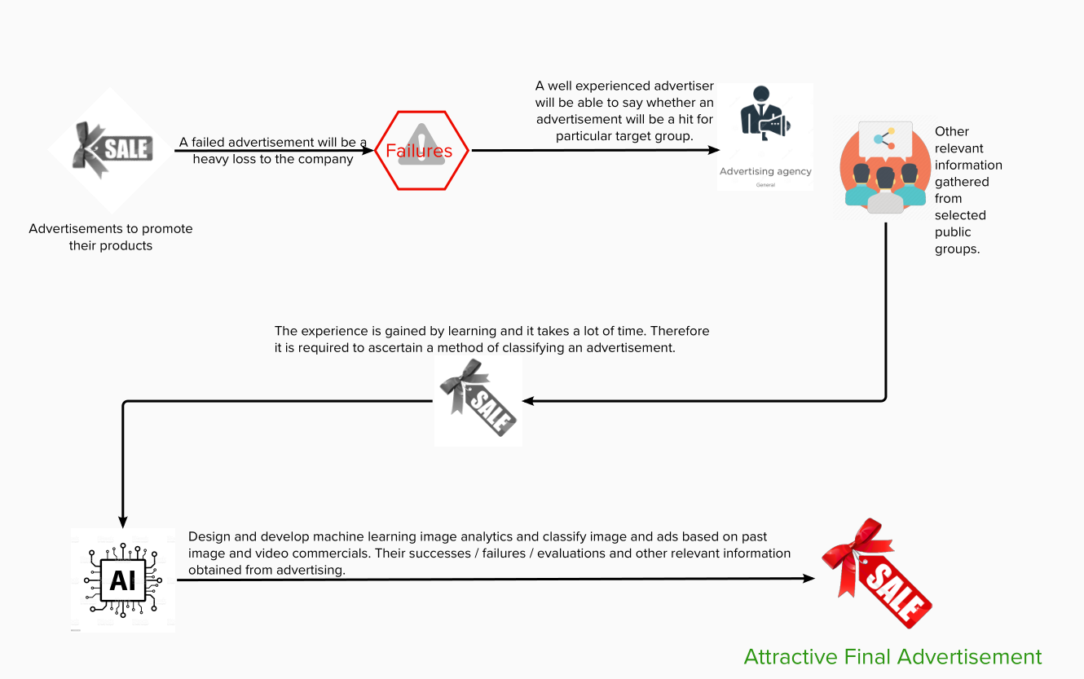
Figure 1.1: Machine Learning based image adverts classification

Objectives
The proposed project addressed the following objectives to meet the expected impact explained in Chapter 4. These are well defined, realistic, measurable and achievable within the time frame of the project.
- Create a large database of image based advertisements and annotate them: Few thousand image based advertisements were collected and annotated them for training, validating and testing the proposed algorithms.
Method of verification: Completed database and make it available for future research.
- User feedback collections: Users were given a questioner (Appendix A1) to rate the advertisements and the collected data was used in training the proposed model(s).
Method of verification: A questioner was included at the Appendix A1.
- Design a Convolutional Neural Network (CNN) based Machine Learning Model for image analytic predictions: A multilayer CNN Model was proposed in rating the image based advertisements.
Method of verification: Model was used in training, validating and testing image based advertisements. The model was presented in Appendix A2.
- Analyse the results of image analytic predictions from the CNN: A detailed analysis of results from CNN were carried out.
Method of verification: Comprehensive analysis of results are presented in Chapter 4.
- Use Explainable AI to understand the significance of features and spatial distributions of information and recommend steps in improving the adverts: Explainable AI modules were developed to provide feedback to the advert designers to improve the advert to achieve its expected performance. Local Interpretable Model-agnostic Explanation (LIME) and Integrated Gradients (IG) were used in examining the inputs of the proposed ML framework on their importance to the output and extract the reasons for the rating.
Method of verification: Comprehensive analysis of results are presented in Chapter 4 and reasoning decisions were evaluated with user evaluations.

Organisation of the report
Rest of the report is organised as follows: Chapter 2 illustrated the related work including an overview to the CNN, LIME and IG. Proposed methodologies were presented in Chapter 3 and the results were analysed in Chapter 4. Chapter 5 concluded the report with an overview to the future work. A comprehensive list of references and appendices were included at the end of the report.

Literature Survey

Market Scenario
Advertising is the one of the creative industries that generates majority of the income for the modern industry particularly to the media industry. Advancement of signal processing and content delivery technologies enables revamp the traditional advertising models for better utilising the precious advertising. Nowadays there are mainly two types of advertisements, with two related ways of sale: traditional advertising, usually sold by human interactions between publisher and advertiser, and targeted advertising, based on user’s data and typically sold through automatic (programmatic) platforms. Targeted advertising is changing the media landscape. In a market already worth over 15 billion Euro, online display advertisements are now routinely bought and sold through automated exchanges. Dynamic AD Insertion (DAI) is the other main advertising technology that currently attracts most media agency interest in Europe, according to a new study from strategy and research consultancy MTM London, sponsored by Adobe [4]. Internet giants such as GOOGLE and YAHOO have been shifted their focus to programmatic advertising and DAI and focused on multi million Euro business models around these concepts. A main advantage of this kind of ADs sales is the use of data about users, useful to create clusters of users with specific tastes and characteristics which are very appealing to BRANDs and retailers compared to their mass advertising.
State-of-the-art digital technologies are a good example of success for the merger between the classical advertising medium and the Internet. They generate a newly enhanced user experience that revels in the use of synergy through the combination of digital technologies, and they are gaining in popularity. Media operators also stand to benefit considerably from this solution. In addition to increases in daily reach figures—a relevant factor for the revenue from sales of ad-display space and the related additional advertising income—there are immense possibilities for new revenue models. Some of them have already been implemented in the last few years. It is impossible for a company to generate true benefits and to satisfy customer demands without well-founded financing. Most Internet and private organizations have a common trait: they offer their contents free of charge to the public. These business models are mainly based on revenue through advertising. The success of companies like Facebook, YouTube, Gumtree, Twitter, as well as RTL and ProSieben Media AG (in Germany) show that this can be a very lucrative business. In order to continue such success in the future it will be necessary to safeguard the attraction of all available advertising spaces in maximising the effectiveness of adverts with respect to clients.
The development of marketable products and their effective distribution form a core competence of any successful company. Today, companies need to develop an efficient communication, propelled by increasing competitive intensity, in order to create competitive advantages and to sustain such advantages on a permanent. In a marketing-specific context, communication becomes a subject of the marketing-mix. Among other marketing instruments, product, price and place, and promotion (communication) assume a central function. The general term communication policy subsumes all the decisions taken by a company, in connection with its communication, and contains both the design of the communication and the information transmission. With regard to manifestations of corporate communication, a distinction is made between external, internal, and interactive communication. However, all of them pursue the goal to manage opinions, attitudes, expectations, and behaviors in a target manner. The aim of a successful advertisement planning process is to reach a maximum level of awareness amongst the recipients. The AIDA model [5] explains the impact of advertising. It described four basic events concerning the effect that advertising causes to a consumer. According to this principle, on which many advertisement strategies are based, advertising should first trigger attention (A) which leads through interest (I) and desire (D) finally to a purchasing action (A) of the consumer[5]. In times of increased information offerings and the associated information overload, more and more receivers of advertisement react with active avoidance. Further, advertisers are confronted with an increased number of possible communication media and instruments. These facts make the planning process more complex and a purpose-oriented communication rather essential.

Related Work
State-of-the-art advertising process involves several tasks. First, specifications are defined based on SWOT analysis followed by defining the objectives and purpose of the advert. Next, research on the market and its competition and target audience are studied. After selecting the desired advertising channel, several brain storming sessions are planned before the advert design process begins. During the advertising design process, it considers several aspects which are briefed in [6]. Figure 2.1 illustrates the conventional advertising process. The focus of the proposed project is to add an intelligence to the advert design process with automatic rating and feedback for the decision. Since the work is based on ML technologies, section 2.3 and section 2.4 summarise how ML has been used in the creative industries.
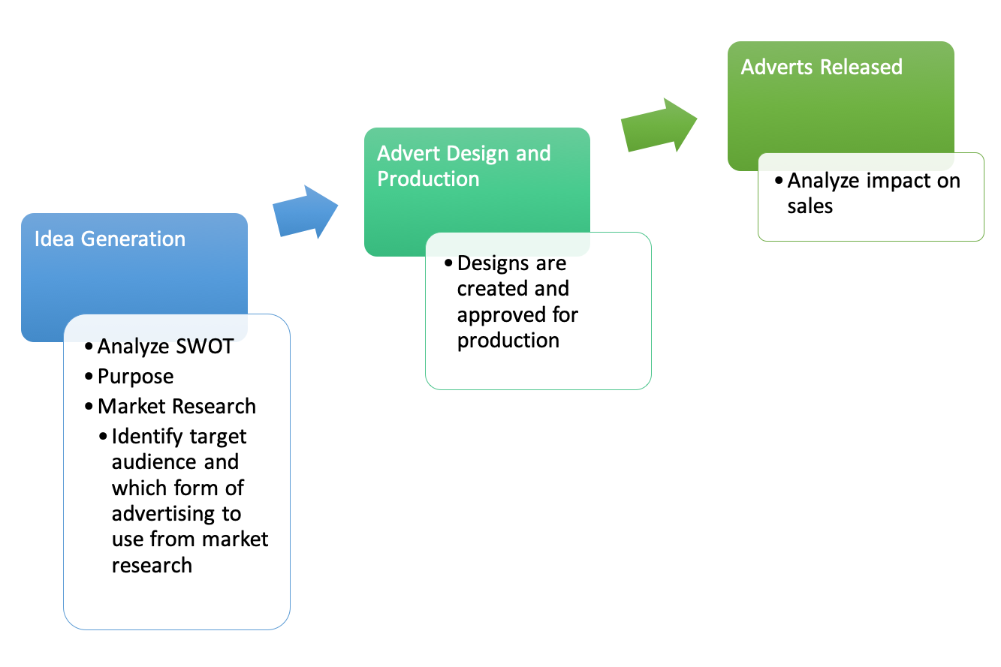
Figure 2.1: Conventional advertising flow

Machine Learning Technologies
Machine learning is defined as per Professor Tom Mitchell of Carnegie Mellon University as the following:
“A computer program is said to learn from experience E with respect to some class of tasks T and performance measure P, if its performance at tasks in T, as measured by P, improves with experience E.” [7]
There are two dominant sectors in ML, supervised and unsupervised; this project follows the practice of supervised ML. Supervised ML implements computer algorithms on labeled datasets of typically an extensive magnitude and classifies data accordingly by iterating through this data. ML has been widely used in many domains and a significant progress has been made in range of different applications. ML is considered as a form of Artificial Intelligence(AI) which can train a computer to understand the environment and think like a brain. It learns from the past experiences by exploring patterns and data with minimum human interventions.

Machine Learning Based Image Classifications
The usage of ML to improve advertising is relatively new, however, there have been some attempts presented in the past literature. Michael Fire et al. [8] used two different major methods of ML to analyse the Click-Through-Rate (CTR) of two large datasets of image advertisements. The first method involved pre-trained CNN and the second method involved k-clustering algorithms which are an unsupervised method of ML. Fire et al. rated the images based on the CTR and used CNN to specify which objects are commonly visible in adverts of high CTR. Then, clusters were used to specify the same, however, this was done in order to categorize the adverts. The final results observed demonstrated that adverts falling in the same category often contained the same items, although some of these objects were redundant in being attractive to the consumer (eg, medicine in beauty product advertisements).
Some work was done in understanding the impact of AI in the advertising industry specially in e-commerce applications. Zhibin Jiang et al.,[9] discussed the impact of AI on the advertising process in China. They considered advertisers, e-commerce platforms and AI in improving efficiency. Jan Kietzmann et al. [10] analysed how marketers can leverage AI. They argued that marketers have been turning to AI to transform big data flows into valuable consumer insight. Mike Kaput[11] discussed how AI can influence the advertising platforms such as impressions, CTR, bid levels, and demographics. Demetrios Vakratsas and Xin Wang[12] discussed how to use AI in advertising creativity. The authors proposed a creative advertising system that is based on AI principles. Muhammad Ehsan Malik et al.,[13] analysed the impact of advertisement and consumer perception on consumer buying behavior. Their study concluded that the consumer buying behavior can be enhanced with creative advertisements. Ali Fahmi et al.,[14] analysed the brand image effect on advertising awareness using a Neuro-Fuzzy and a Neural Network prediction models. They proposed to use adaptive neuro-fuzzy inference system and Artificial Neural Network to analyze advertising decision making. However, the results were not conclusive.
Wan-Chen Wang et al.,[15] tried to model the consumer responses to advertising slogans through Artificial Neural Networks (ANN). They also wanted to achieve an in-depth understanding of consumers’ emotional responses to advertising slogans and their effect on the development of advertising effectiveness. There were several other works has also been reported in understanding the emotional attributes of users in consuming adverts using AI technologies [16][17]. They argued ranking emotional attributes through preferences learning methods generated significant advantages over conventional approaches. An Tien et al., proposed an image classification model applied for identifying the display of the online advertisement using CNN [25]. Their application of CNN was very limited in analysing the image based adverts.
Therefore, based on the publicly available literature, it is evidenced that there is no ML based image analytics framework to automatically rate image advertisements for creating a rich targeted advertising ecosystem and provide feedback to advert designers in improving the quality of the adverts which is the main focus in this research. Section 2.4.1 and section 2.4.2 briefly explains the concepts of CNN and Explainable AI.

Convolutional Neural Networks
A CNN is a type of ANN which consists of a multitude of layers. CNNs have an input and output layers and one or more hidden layers in between. Figure 2.2 presents an overview to the CNN. Unlike ML algorithms such as Logistic Regression, CNN has the capability of extracting features by itself and therefore they are highly efficient in classifications. During the classification phase, there are several convolutional and pooling stages. While each convolutional layers are used in extracting features, pooling layers are used in reducing the dimensions based on a pre-determined criteria depending on the application. It follows an efficient hierarchical model in building a funnel like network and produce a fully-connected layer with all neurons are connected to each other. CNN is considered to be very efficient in image understanding.
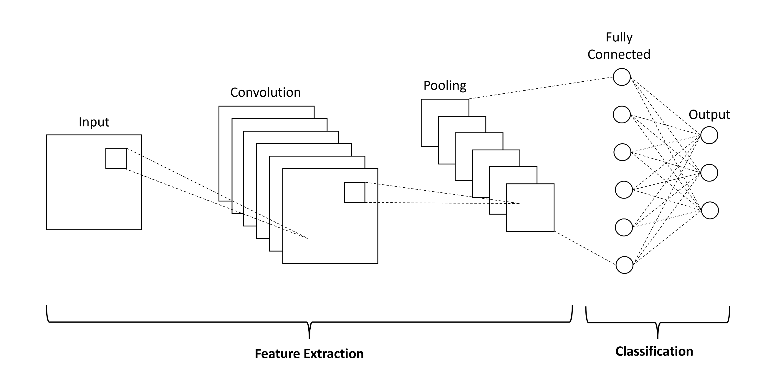
Figure 2.2: Concept of CNN modelling

Explainable AI
Explainable Artificial Intelligence (XAI) is relatively a new concept. The idea of the XAI is to provide reasoning in understanding and interpreting the predictions made from a ML model. The output of an XAI module will be very useful in understanding the data and make corrective actions in improving the overall performance.
The use of Deep Neural Networks(DNN) has increased significantly in recent years due to the improvement of CPU and GPU growth, allowing DNNs to achieve state-of-the-art results in most areas. Continued advances promise to produce autonomous systems that will perceive, learn, decide, and act independently. However, the effectiveness of these systems is working as a black-box model, and it is limited by the machine's current inability to explain their decisions to create trust among humans. The opacity of deep learning models makes them difficult to interpret; hence they are not widely adopted in critical fields such as medicine. That is why increasing autonomy, complexity, and ambiguity in AI methods continue to increase the need for interpretability, transparency, understandability, and explainability of AI products/outputs.
But, there is a tradeoff between AI accuracy and explainability. The most accurate methods, such as CNNs, provide no explanations; understandable ways, such as rule-based, tend to be less accurate. XAI will come in to solve this issue. An XAI system can be defined as “a self-explanatory intelligent system that describes the reasoning behind its decisions and predictions”[18]. Adding an explainable component to a ML pipeline provides model interpretability and enables business stakeholders to gain trust in the model or may be used to assess and fix the systematic bias in the model without compromising the model output and performance. Many XAI methods are introduced to get the interpretation of the results without reducing the accuracy. The methods can generally be divided into two main streams: Forward-pass (or input) based attribution and Backwards-pass (or gradient) based attribution models. Forward-pass (or input) based attribution models are model-agnostic. The central intuition behind these models is quite simple. Considering an input image; make some adjustments to the input, and observe the effect on the predictions. Adjustments can include partial occlusion or perturbation of parts of the input. The most well-known example is Local Interpretable Model-agnostic Explanations (or LIME). Another approach is Backpropagation-based methods which compute the attributions for all input features in a single forward and backwards pass through the network. While these methods are generally faster than perturbation-based methods, their outcome can hardly be directly related to an output variation. Gradient Input, Integrated Gradient and DeepLift are some of the examples of this kind of approach. Within this research, two interpretable models (LIME [19] and IG [20,21]) are used to analyse the CNN classified images. Following sections briefly presents the basics of LIME and IG.

Local interpretable model-agnostic explanation (LIME) is an interpretable model used to explain individual predictions of black-box machine learning models. LIME has the following characteristics [19]
Local: Explanations are locally faithful instead of globally. Instead of training a global surrogate model, LIME focuses on training local surrogate models to explain individual predictions
Interpretable: Humans are limited by the amount of information that can be processed and understood
Model-Agnostic: Any ML algorithm can be used as a predictive model. It works with text, image and tabular data.
Explanations: Artifacts that provide an understanding of the input to the model and the model’s prediction
LIME measures the changes to the predictions when the variations of the data passed into the ML model.
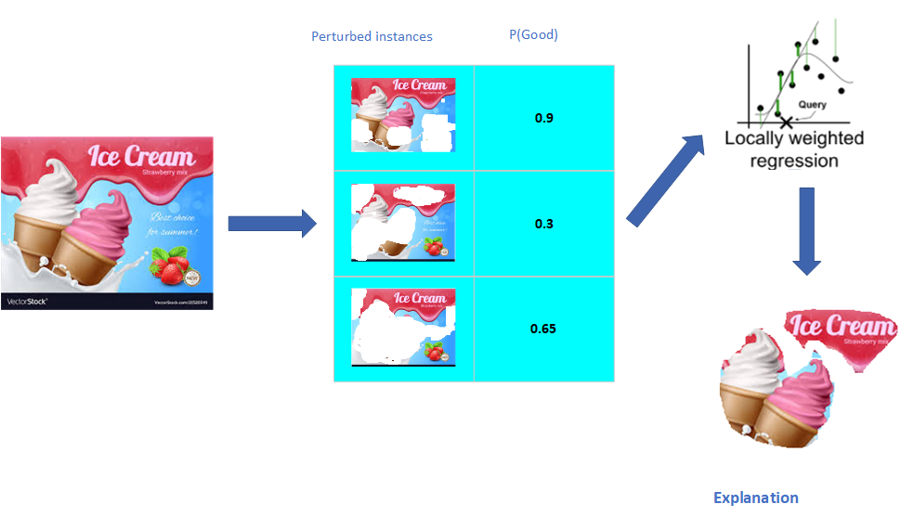
Figure 2.3: Explaining the predicted results based on the LIME approach
As shown in the Figure 2.3, LIME generates a new dataset consisting of perturbed samples and the corresponding predictions of the black box model [19]. LIME predicts new labels for the new dataset with the trained ML model on this generated dataset. Then, a simpler model with intrinsic interpretability, for instance, a linear regression model, is fitted and used to explain the classifier’s prediction. Before fitting a simpler model, the instances in the newly generated dataset are weighted based on their distance to the original instance being explained. Following are the detailed steps to interpret the results of each test instance [19].
- Given an observation, permute it to create replicated feature data with slight value modifications.
- Between original observation and permuted observations similarity distance measure is computed.
- Apply a selected ML model to predict outcomes of permuted data.
- Select m number of features to best describe predicted outcomes.
- A simple model is fitted to the permuted data, explaining the complex model outcome with m features from the permuted data weighted by its similarity to the original observation.
- Resulting feature weights are used to explain local behaviour.
LIME for advertisement images works differently than LIME for tabular data and text. Intuitively, it would not make much sense to perturb individual pixels since many more than one pixel contributes to one class. Randomly changing individual pixels would probably not change the predictions by much. Therefore, variations of the images are created by segmenting the image into “superpixels” and turning superpixels off or on. Superpixels are interconnected pixels with similar colours and can be turned off by replacing each pixel with a user-defined colour such as grey. The user can also specify a probability for turning off a superpixel in each permutation.

Integrated gradient approach
Integrated Gradients (IG) [20] make it possible to examine the inputs of a deep learning model on their importance to the output. In deep learning models, the hidden layers significantly blur this relationship between input and output since there is no direct link between the first and last layer. In a model with a hundred neurons, it is already impractical to follow the path of a data set through the network to be able to interpret how the model works and which features are of interest. Prime objective of IG is to explain the relationship between a model’s predictions regarding its features. It has many use cases, including understanding feature importance, identifying data skew, and debugging model performance.

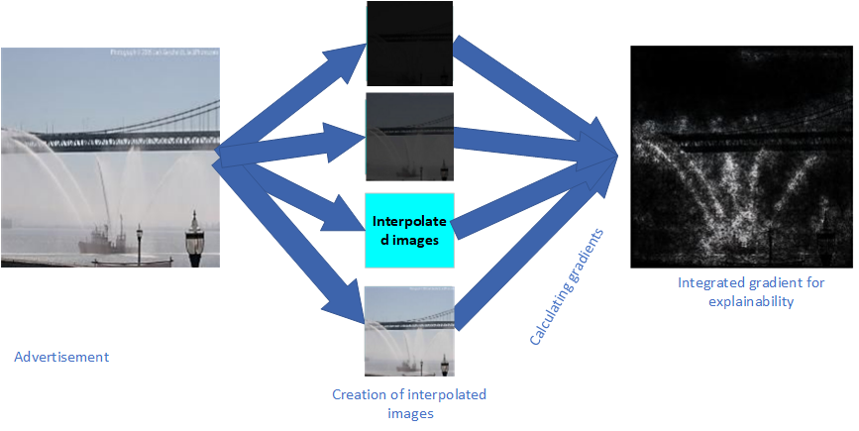
Figure 2.4: Explaining the predicted results using the IG approach
As shown in the Figure 2.4, linear interpolation images are generated between the black image as a baseline and the original advertisement image. Interpolated images are small steps in the feature space between your baseline and input image and consistently increase with each interpolated image's intensity. Gradients are calculated using those interpolated images to measure the relationship between changes to a feature and changes in the model's predictions. The numerical approximation is computed next through averaging gradients to ensure that the attribution values are accumulated across multiple interpolated images and are all in the same units as shown in Figure 2.5.
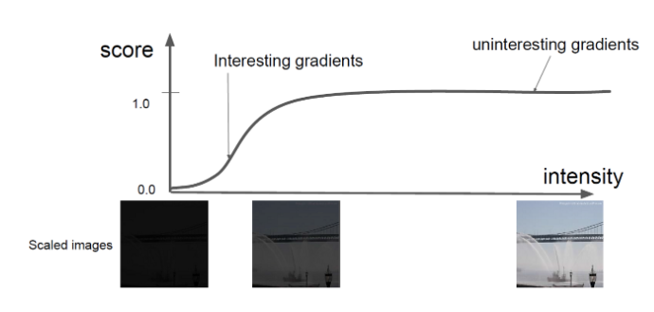
Figure 2.5: Gradient change with interpolated images [21]
Region of interest lies where the slope of the score vs intensity graph. It doesn’t remain constant which is marked as the interesting gradients. The integration of these series of gradients give the IG of the image.

Proposed Framework and Methodology

Conventional advert creation process
Conventional advert creation process involves defining requirements, brain storming, advert design process, launching the advert and quantifying and analysing the impact of the advert. As per the current state-of-the-art, advert design process (highlighted in the Figure 3.1) does not involve any intelligence. This proposed research adds an intelligence to predict the customer ratings for the advert and provides reasoning and interpreting predictions which will help to the advert designer to improve the quality of the advert. It will help to minimise the burden on the most expensive part of the advertising value chain (launching the advert) and minimise the risks of a failing advert. Figure 3.1 illustrates the conventional adverting creation process and how the proposed framework is integrated to the conventional system. Initially, a comprehensive image data base is created and annotate them. Annotated images are used in collecting the user feedback/ratings. Within the next phase, CNN is developed and trained from the created data base. During the final phase of the project, XAI models based on LIME and IG are developed. In order to perform XAI operations, predicted CNN model is shared with the XAI together with the predicted user ratings from the CNN. Reasoning/interpreting predictions are finally fed back to the advert design process which can be used to improve the quality of the advert.
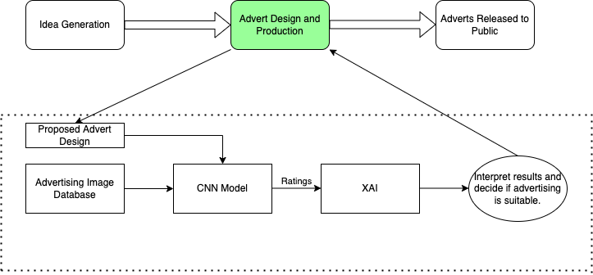

Figure 3.1: The proposed ML based advert rating system

The initial step of the methodology is to define specifications and requirements for the proposed system architecture and reference scenarios. These requirements were utilised as a starting point in the system modules that were developed during the project. These plans and requirements were updated and modified during the work depending on the literature and market conditions. This was in response to the research results produced within the project, and also in response to any external factors (e.g. results in other research work, changing market conditions, etc.), which was identified in during the innovations management. However, final set of specifications used in the research are presented in the section 3.2.
Methodology involved defining specifications, designing and developing the CNN model. Once the CNN model was fully developed and validated, both models were fully tested with a set of independent adverts. Results was combined in developing an XAI in understanding the reasons for the ranking and provide a set of useful feedbacks to the advert designers in improving the quality of the adverts. Finally, the complete end-to-end system was fully integrated and demonstrated.
The project implementation was divided into three phases, as shown in Figure 3.2. The first phase consists of planning, architecture design, and initial research to achieve project objectives. System components was designed and prototypes was developed in the second phase of the project. Initial integration was performed during this phase. The results of this initial integration were fed back into the algorithm design to allow refinement of the proposed technologies. These developments were demonstrated at the end of this phase. The third phase was devoted to the final integration of the system components, integration for the demonstrator, evaluation and benchmarking.
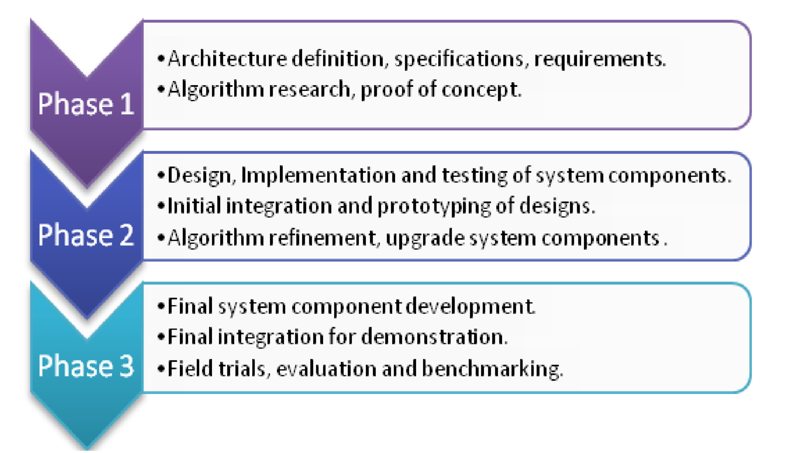
Figure 3.2: Project phases

Specifications
The main purpose of this task was to sketch and form the overall system open architecture, in an end-to-end fashion. The practicality of implementation, technical challenges to build up and bind together the blocks, the excellence the system was brought with respect to the current state of competitors and the new dimensions the project could bring in the proposed advertising system. The architecture was based on open standards in order to represent a reference model also for future SMEs/creative industries aiming at providing added-value services on top of it. Following specifications was used throughout the project.
Image advertisement data base:
Number of images : 1,200
Images generated from augmentation : 3,600
Image size : varied between CIF to HD images
Input mapping image size to CNN/LR : 256x256
Percentage of images used for training : 70%
Percentage of images used for validation : 15%
Percentage of images used for training : 15%

CNN parameters:
Number of convolutional layers : 4
Number of pooling layers : 4
Number of dense layers : 2

LIME parameters:
Gaussian kernel size : 4
Cut-off point for data distances : 200
Number of perturbations : 20

NG/IG parameters:
Number of interpolation steps : 50
Number of baseline images : 2

Methods of verifications:
Model: Since there was no appropriate state-of-the-art technology available for benchmarking results, the models were verified by confirming the model parameters and pipeline used.
Coding: Since there was no appropriate reference and/or database for this proposed work to compare the results, the coding was reviewed by one of the supervisors manually to make sure the it has been developed correctly.

Engineering judgement
In order to achieve the proposed objectives, it can be considered several deep learning and ML algorithms such as DNN, RNN, RCNN (combined RNN and CNN) and Logistic Regression. Since images have a very high spatial correlation, CNN was identified as a better candidate for achieving the anticipated objectives. Furthermore, it is more computationally inexpensive compared to other algorithms such as Transformer [26] and RCNN. Therefore, CNN has been selected as the main candidate for the rating prediction algorithm.
Though XAI is still an emerging technology, there are few algorithms such as LIME, NG, IG, SHAP reported in the literature. Due to the time and computational constraints, only NG, IG and LIME were implemented and integrated to CNN in testing the overall system.
Section 3.4-3.7 briefly describe the proposed CNN, LIME and IG models.

CNN based approach
With more data and labels, a CNN model can automatically extract features from the advertisement image. A CNN model can be thought to be a combination of two components: the feature extraction and classification parts. The convolution and pooling layers perform feature extraction while fully connected dense layers performs the classification. The convolutional layer consists of digital filters to achieve the convolution operation on the advertisement image. The pooling layer is used as a dimensionality reduction layer. The specified advertisement image is initially forwarded to convolutional and pooling layers, and then the resultant extracted features are sent to the dense layer for classification. Figure 3.3 presents the proposed CNN based model.
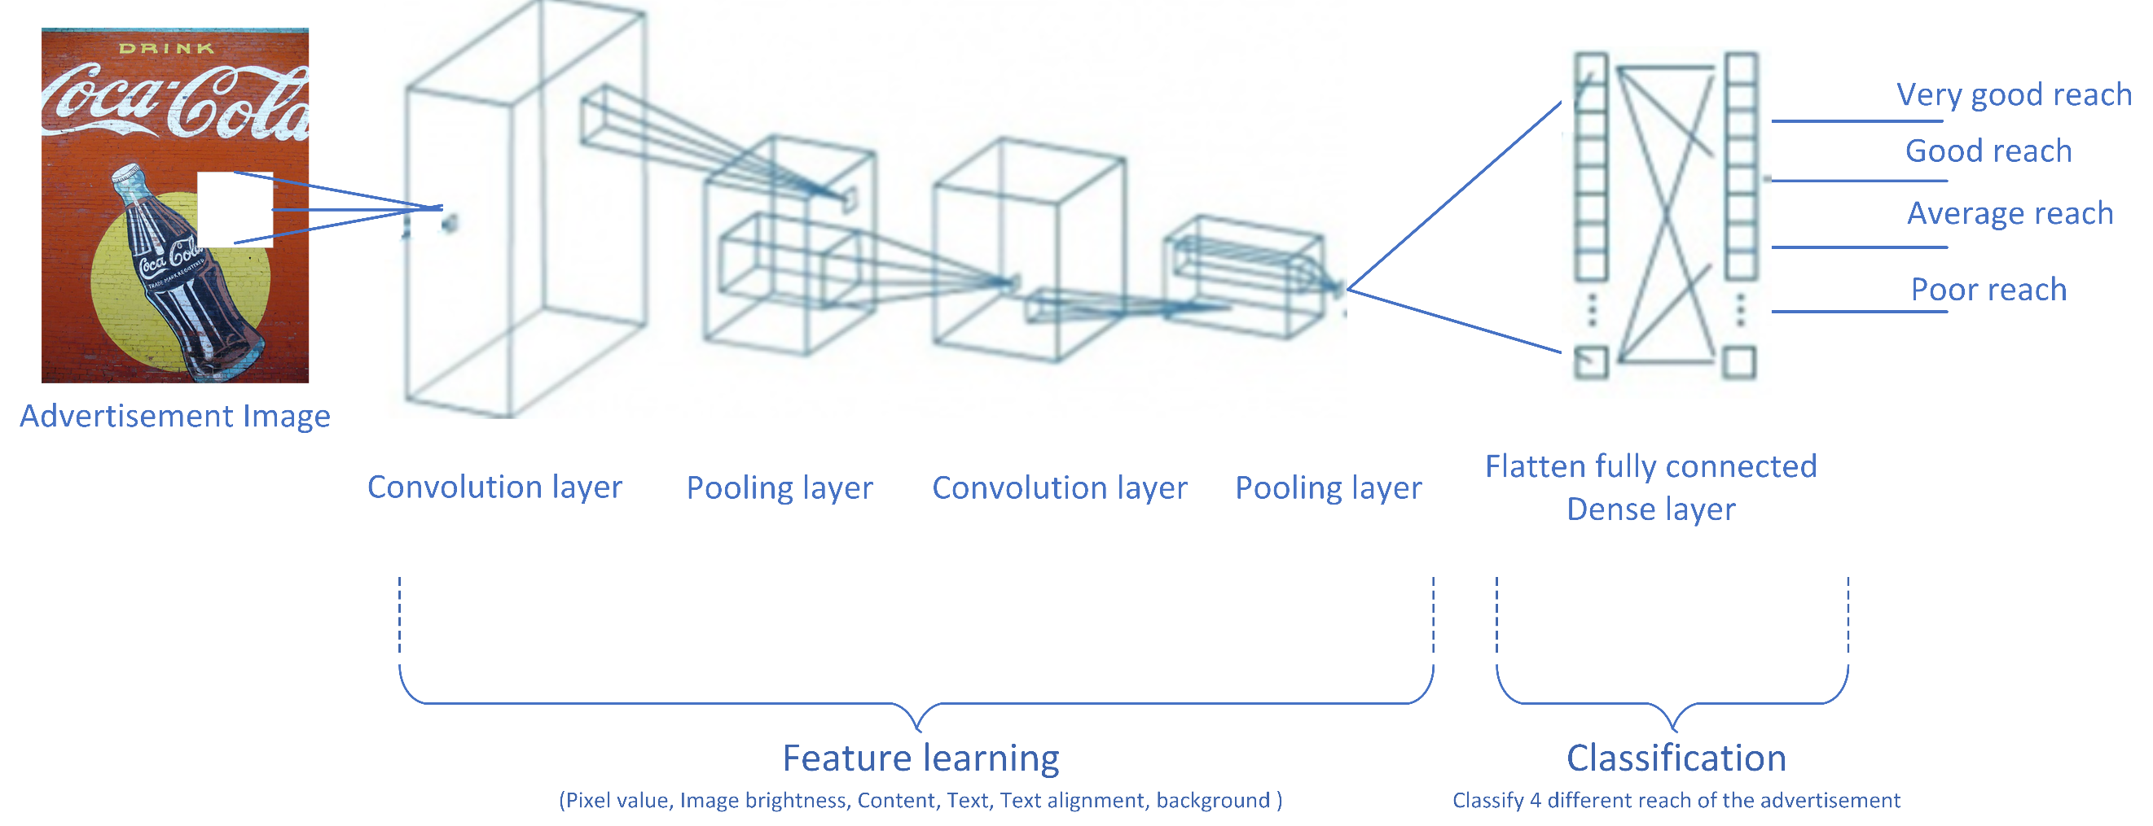Figure 3.3: Proposed CNN model

Explainable AI
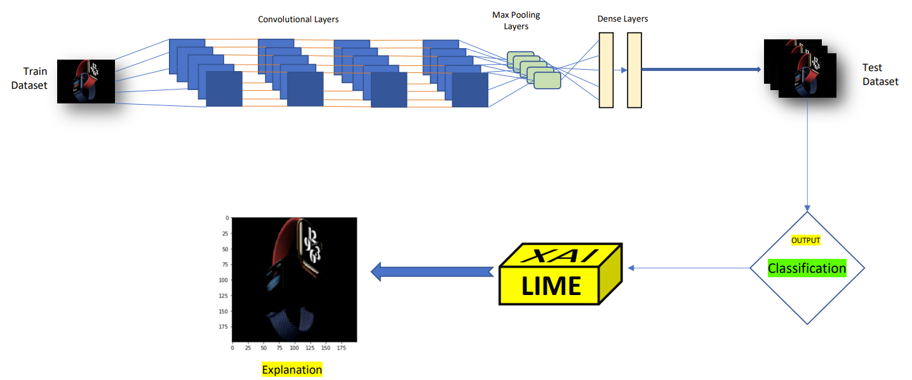

Figure 3.4: Proposed LIME model

Like explained in the chapter 2, XAI helps content makers in interpretation of black-box models and their decision-making process to verify why an advertisement performed well that is extremely important in the content creation and processing field. Figure 3.4 and Figure 3.5 illustrate the proposed LIME and LG models respectively.
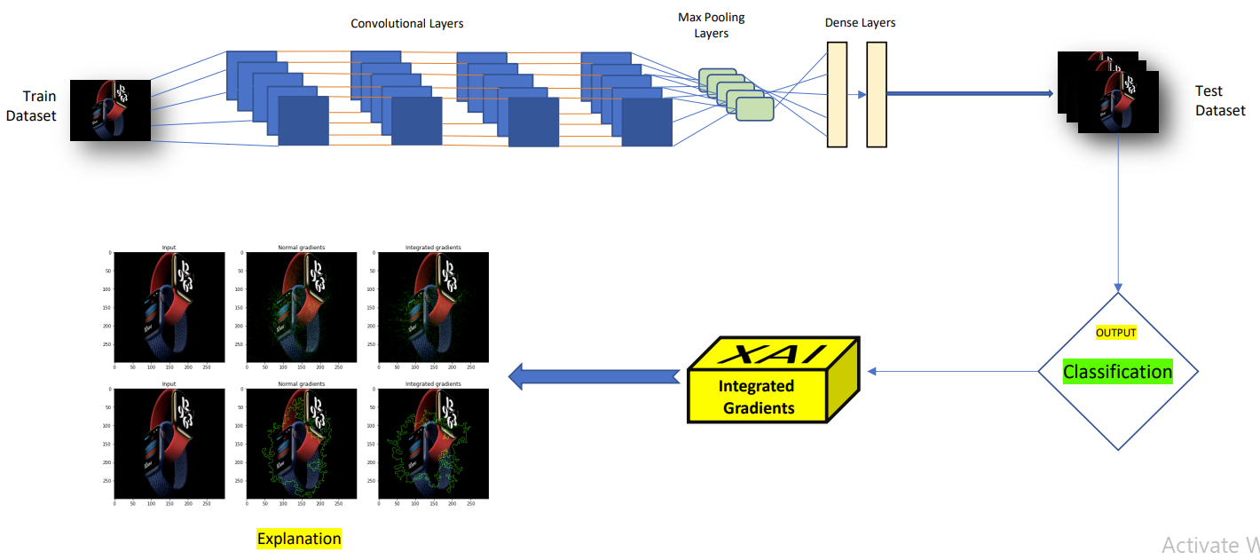

Figure 3.5: Proposed IG model

Demonstration and performance evaluation

The definition of a solid integration plan was vital to ensure that the integration process was carried out smoothly. Concurrently with the development of the design specifications of the different components and especially with the design of the overall architecture, this task performed an integration plan that could describe the strategy for the integration of all components into an open test bed platform. The demonstration and validation strategy were based on a 2-phases testing cycle, the earliest based on the testing of the “Beta” integrated system and the latest aiming at testing the final integrated system. For this purpose, such integrated system was properly configured in order to best match the characteristics of each pilot context and requirements.

Key Performance Indicators (KPI)

Impact of the proposed technologies was measured and demonstrated by the detailed analysis of quantitative and qualitative KPIs by the comparison of two panels of industries/consumers, one using the proposed solution and the other without the solution. Summarised results were presented in the Chapter 4. KPIs such as the increase of the average number of purchases per customer; reduction of costs; enhance revenue for advertisers and Return on Investment (ROI) were important indicators of measuring the impact of the proposed technologies. However due to the time and practicality of implementing the proposed models with an advertiser and in the complete advertising value chain (as shown in the Figure 3.1), analysing this KPI is considered as a future work which is explained in Chapter 5.

Challenges and mitigation plans

Due to the nature of any technical research project, certain technical and non-technical challenges were envisaged throughout its life cycle. Followings bullet points illustrate some of the major challenges encountered during the project and how they were mitigated. These challenges/contingencies were conceived based on the work completed.
- Algorithms were too resource intensive: Sub-optimal solutions requiring minimum amount of resources was considered. Reduced number of layers and neurons were selected for the CNN implementation.
- Originally it was planned to consider Logistic Regression as a ML algorithm in rating the image adverts. However, it was understood that Logistic Regression was not suitable for the rating classification since it is not suitable for image classifications. Therefore, the thesis only presents the results of CNN. This challenge was easily mitigated since the overall framework was not affected by this decision.
- Information required to make the correct optimisation decision was incomplete: Size of the image database was not sufficient in implementing CNN. Image augmentation was used to generate additional images.
- Delay in ethical approval: Ethical approval for user rating collection was delayed more that it was planned before. Algorithms and other frame work were completed in advance while waiting for the approval. Furthermore, time was efficiently managed in achieving the original time scale.
- Effect of the pandemic: The recent pandemic effected significantly for user feedback collections. Collection of the data beyond national boundaries mitigated this challenge.

Results and Discussion

Within this Chapter, the performance of LR and CNN prediction results are presented and analysed. Furthermore, integrated CNN with LIME, NG and IG are considered. Comparisons between LIME and NG/IG with user feedback are also discussed followed by computational analysis of different models. Finally, the impact of the proposed framework is suggested. All simulation results are based on the specifications defined in the Chapter 3.

Database creation

A collection of 2,000 image adverts were collected and annotated them with ratings as explained in the Chapter 3. In order to expand the database, different image augmentations were performed. Figure 4.1 depicts an example for an image augmentation by flipping the image. For the models, these augmented images are considered as a new image. Finally, approximately 5,000 images were created and of which 70% of images were used to train the models and 15% of images were used for validation and testing.


Figure 4.1: Example of image augmentation

Table 4.1 depicts the prediction percentages for both LR and CNN models for different classes of adverts. Though both models can predict the rating with a higher percentage, CNN clearly outperform LR. This is mainly due to the superior properties inherited in CNN in image classifications. Spatial correlations within images are exploited well in CNN. Results are also shown that ratings are independent of the advert categories.
Advert Category | CNN Predicted Accuracy
1 (Cars) | 92%
2 (Food) | 89%
3 (Furniture) | 87%
4 (Fragrance) | 91%
5 (Fashion) | 88%
6 (Chocolate) | 90%
7 (Phone) | 91%
8 (Electronics) | 93%
9 (Humans) | 94%
10 (Drinks) | 93%
Table 4.1: Performance analysis of LR and CNN

Performance analysis of LIME models

Fifty images were considered during the testing phase of LIME. Table 4.2 presents the feature prediction results from the LIME XAI algorithm for some selected images. Left and right columns illustrate the target image and the feature prediction image respectively. CNN rating is also provided under each target image which will help to understand the predictions proposed by LIME. In the feature predictions, black area is considered as the not important area. LIME predicts the other area as the main reason for predicting the results made by the models. For example, in the first image pair shown in Figure 4.2, CNN rate the advert as a good image and LIME predicts the main reason for the CNN decision is based on the two watches at the middle of the image. In the table, there were three categories of image ratings: Good, Average and Bad. For those who was classified as Good, there was a human or an object clearly distinguished from the background. In a real-world scenario, an advert like that has a very high potential to attract user attention. Crowded images, blurred images or images with texts trended to be classified as Bad images. LIME was able to understand the reasons for these ratings. In an Average rating, still the human and/or the object was considered as the main reason while the portion of the area occupied by it tilted the classification towards an Average rating. That was also picked by LIME.

Target Image | Feature predictions from LIME
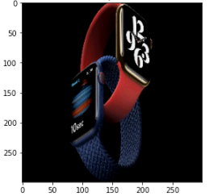  Advert 1: Rating from CNN - Good | 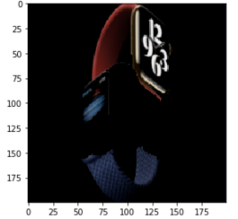
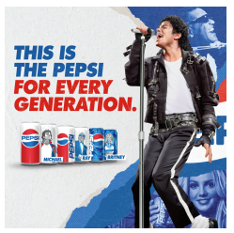  Advert 2: Rating from CNN - Good | 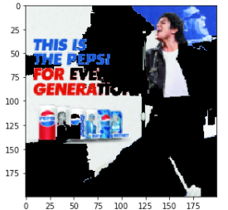
  Advert 3: Rating from CNN - Good | 
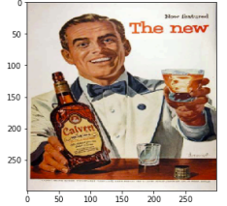  Advert 4: Rating from CNN - Good | 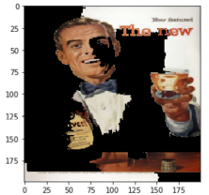
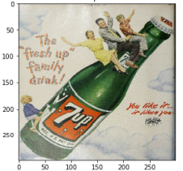  Advert 5: Rating from CNN - Good | 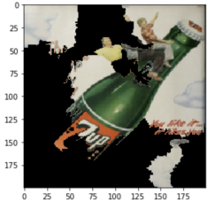
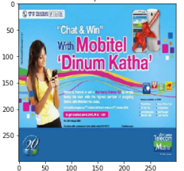  Advert 6: Rating from CNN - Average | 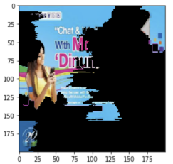
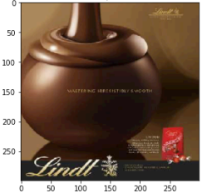  Advert 7: Rating from CNN - Bad | 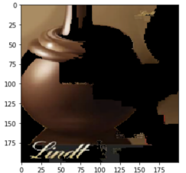
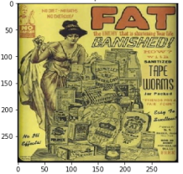  Advert 8: Rating from CNN - Bad | 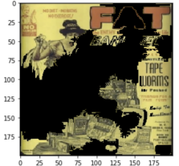
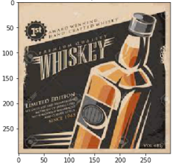  Advert 9: Rating from CNN - Bad | 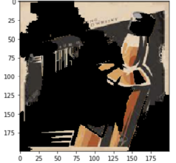
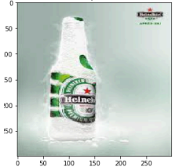  Advert 10: Rating from CNN - Bad | 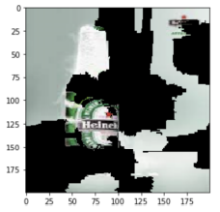

Table 4.2: Performance analysis of LIME

Performance analysis of NG and IG models

Same fifty images which were used in LIME in section 4.4, were considered for testing the performance of NG and IG models as well. Figure 4.3 presents the results with following legends.

Top left: identified regions with NG
Top right: identified regions with IG
Bottom left: most dominant contour with NG
Bottom right: most dominant contour for IG

Figure 4.2 clearly illustrates the key identified region and contours for the CNN decision making in both NG and IG models. Like in LIME, both NG and IG identified the main object or human and the quality of the image as the reasons for the CNN decision. If the same example is considered, in the first image pair, CNN rate the advert as a good image and both NG and IG also predict the main reason for the CNN decision is based on the watche at the middle of the image.

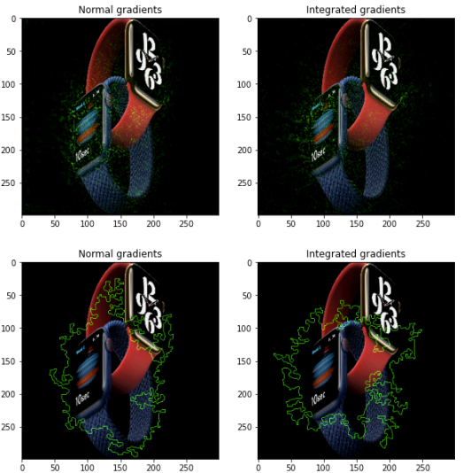
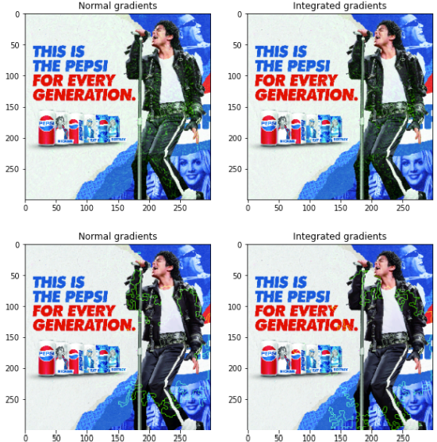
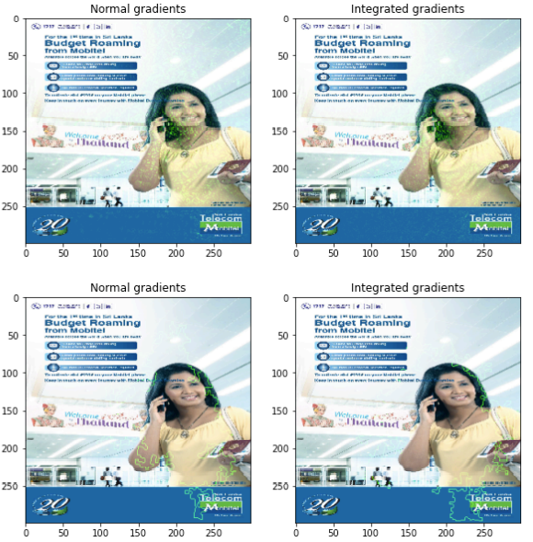
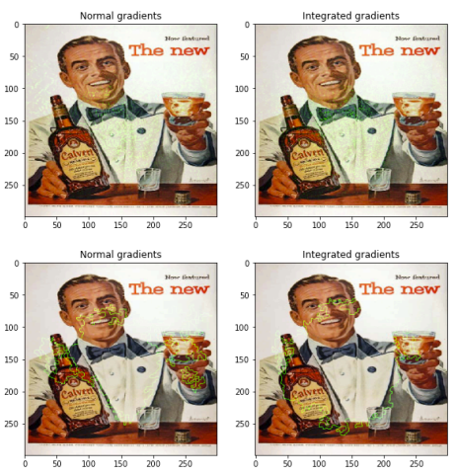
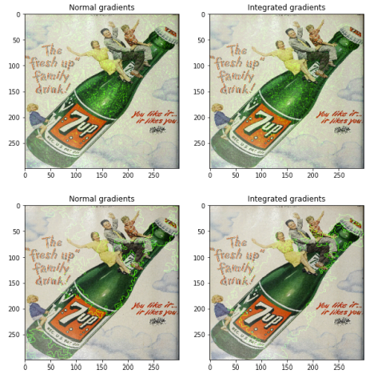
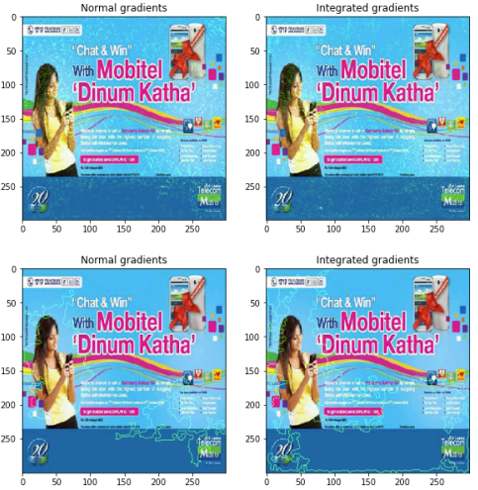

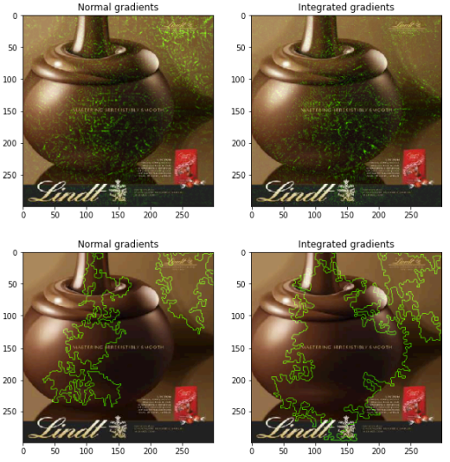



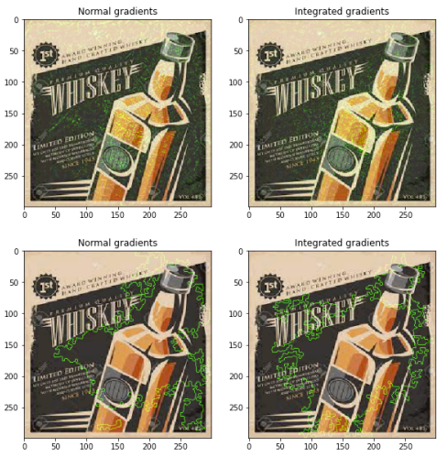
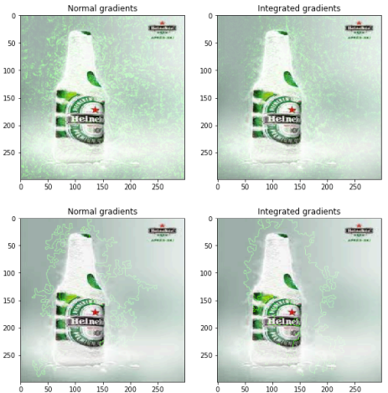
Figure 4.2: Performance evaluation of NG and IG

Performance comparisons of XAI models

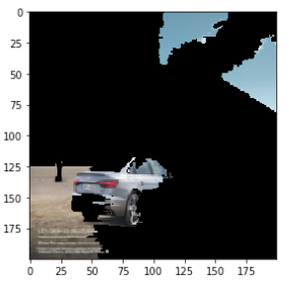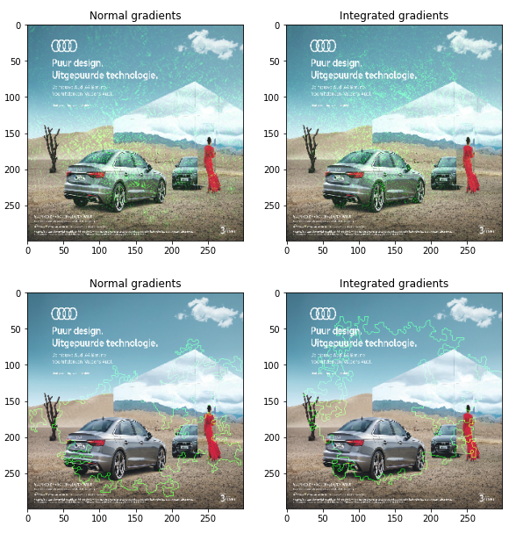

- LIME (b) NG and IG
Figure 4.3: Performance comparisons between LIME, NG and IG

Figure 4.3 presents a particular advertisement which was rated as “good” by the CNN and Figure 4.3 (a) and Figure 4.3 (b) illustrate the LIME and NG/IG model explanations respectively. Both approaches highlighted the car region as the explanation for the results. Though there is a high overlap in both areas, there are few observable differences in the explanation. In the LIME approach, pixels are grouped and made as “superpixels” to decide the most relevant superpixels. There are three superpixels identified for the “good” rate in the LIME approach. In contrast, an IG uses the pixels for each interpolated image. Therefore, they try to identify pixels contributing to the decision. That may be the reason for more concise region selection in the IG approach. Other than that, LIME identifies the neighborhood of the data instance of interest to build a simple model to explain the results. But, the correct definition of the neighborhood is very not well defined. Different neighborhood values will result in other regions of interest.
Twenty users have been asked to evaluate the explanations provided by LIME and NG/IG. The users were asked “Are you agreeing with the model explanations in rating the advert?” Table 4.3 summarises their feedback. Results indicate that there was very high correlation with the model explanations and how users thought. As clearly visible from the Figure 4.3 and Table 4.3, IG performed really well followed by NG and LIME. For the ratings rated as “bad”, LIME was struggling to agree with the user’s feedback. This could be explained since LIME works on the concept of superpixels as explained before.
Advert | LIME | NG | IG
Advert 1 | 100% | 100% | 100%
Advert 2 | 100% | 100% | 100%
Advert 3 | 100% | 100% | 100%
Advert 4 | 100% | 100% | 100%
Advert 5 | 100% | 100% | 100%
Advert 6 | 90% | 95% | 100%
Advert 7 | 95% | 100% | 100%
Advert 8 | 70% | 90% | 100%
Advert 9 | 70% | 95% | 100%
Advert 10 | 60% | 95% | 100%
Table 4.3: User feedback evaluation for LIME, NG and IG

Computational complexity analysis

This section analyses the computational complexities of the proposed models. Several assumptions were made in calculating the computational cost for different models since they cannot be mathematically calculated due to the nature of the DNN properties. Following subsections presents the calculations for the LR [21] and CNN [22,23] models considered.

Logistic Regression

Training phase: The linear regression can be computed as (X^{T}X)⁻¹ X^{T} Y, where X is a n×k matrix, Y is nx1 matrix. The complexity of the matrix product AB is O(abc) whenever A is a×b and B is b×c. Therefore, it can be evaluated the following complexities:
- The matrix product X′X with complexity O(k²n).
- The matrix-vector product X′Y with complexity O(kn).
- The inverse (X′X) ⁻¹ with complexity O(k³)
- The final matrix multiplication of (k x k) and (k x 1) matrices takes O(k²) time
Therefore, the Big-O training time is O(k² n+ k³ + kn +k² ). So, asymptotically, the actual Big O running time is: O(k²n + k³) = O(k²(n + k)). The space complexity while training is O(nk + n).

Testing Phase: After training the model, W and b can be evaluated. W is basically a vector of dimension k. Given any new point, it can perform the operation W^{T}X_{i} + b. Where, W is a vector of size k. Performing the operation W^{T}X_{i} + b takes O(k) steps. Therefore, runtime complexity of LR is O(k). The space complexity of W can be calculated as O(k). Finally, the space complexity of LR at run time is in the order of k or O(k).

CNN

Complexity of CNN depends on the number of neurons, number of layers and convolution filters.
Forward propagation: Assuming there are n layers each with n neurons, the total run-time of forward propagation can be calculated as O(n⁴).
Backward Propagation: Assuming the gradient descent runs for n iterations, and that there are n layers each with n neurons, it can be shown that the total run-time of backpropagation is O(n⁵).
Therefore, Big O notation of training phase is O(n⁵) and testing phase is O(n⁴). Where, n stands for the number of neurons.

LIME

Assuming there are n number of parameters in a neuron and n number of neurons in the trained mode, computational complexity of LIME can be calculated as O(n⁴) for each permuted data. It should be noted that this is an additional complexity to the CNN model training and testing complexity.

Integrated gradient

For each interpolated image in the Integrated gradient, gradient values needed to be calculated with the forward pass which is considered to be the most dominant factor. Assuming, there are n number of parameters in a neuron and n number of neurons in the trained mode, computational complexity of this can be calculated as O(n⁴) for each interpolated image. Similar to LIME approach, this is an additional complexity to the CNN model training and testing complexity.
In Summary, LR training phase is far less complex than CNN models. There are no additional steps needed in the LIME and IG approach in the model training phase. Therefore, training complexities of LIME and IG shall be deemed as same as CNN. LR testing phase is also less complex than CNN with more neurons. As IG and LIME need additional steps to explain the test results, testing complexities of integrated gradient and LIME are higher than CNN. Yet, Integrated gradient tends to be faster than LIME and consume less memory as number of additional processes are lower in integrated gradient than LIME.

Impact of the research

Academic impact

The project focuses on key research areas in the field of creative industries (advertising), vision technology, machine learning and autonomous systems. The proposed concept and solution demand development of novel techniques and approaches and their application in creative arts, vision processing, scene understanding, action recognition over next generation requirements on trusted autonomous systems based on user requirements. As the system proposed is not currently available, the work done within the project will provide substantial knowledge to researchers and academics.
Academic beneficiaries:
1. Researchers in the fields of image processing will benefit from novel AI approach for image understanding in within the context of semantic scene understanding and attribution.
2. Researchers in the fields of computer vision will benefit from novel feature extraction for attribute detection needed for the creative structures and processes trained into the AI models.
3. Researchers in the fields of creative arts in humanities will benefit from novel structures and processes developed for AI models for immersive content generation in time constrained scenarios.
4. Researchers in the field of security and trusted systems will benefit from novel approaches in secure system architecture and training of AI models to work with different applications.
The knowledge gained will be disseminated through a research publication and/or a conference publication. The research will impact researchers in these areas both in the UK and internationally.

Economic and social impact

Advertisers and who uses advertisements (SMEs and major companies and individuals) will get the major economic benefit of the project through its ability to design the adverts in a more productive manner in cutting down the cost and enhance the success of reaching the advertises with a higher target rate. It can be expected to increase in revenue for many entities in the advertising value chain. In the meantime, advertisers will experience a reduced Cost Per Impression (CPI) for the advertisements they create. This is because the solution can now reach the right audience for a given advertisement. Furthermore, this reduced CPI will create more skilled job opportunities in the advertising sector which already has a strong work force of 550,000 in UK and eliminate the cost barriers for SMEs and individuals to advertise to get to right audience to improve their revenue potential.
Proposed concepts will have a significant impact on social media content creations which is explained in Chapter 6 under future work. It will also help individuals to create their own advertisements without expert’s involvement. It will help to create social driven advertising which will have a great impact on how E-commers will involve in the future.

Conclusions and Future Work

Conclusions

The proposed work concentrated on designing a framework and develop a ML based image analytics to automatically rate image advertisements for creating a rich targeted advertising ecosystem for advert designers. In response, LR and CNN models were proposed. The explainable advertisement classifiers (LIME, NG and LG) were used as a second opinion provider to create better and more impactful advertisements. Even though artificial intelligence (AI) is applied in almost all areas, the usage of AI for advertisement rating has not been utilised based on the current literature. Other than that, an AI-based system for general image classification can only provide predictions without explaining its decision. XAI methods proposed here are intended to meet this need.
During the project, different approaches are experimented to classify the advertisement ratings and explain those results. Experimental results suggested that CNN provided 90% accuracy in average, while the LR model provided 70% accuracy on average. It was also shown that how LIME and NG and IG approaches can be utilised to explain the results predicted using the CNN approach. Both approaches highlighted the regions as the explanation for the results. Though there is a high overlap in three approaches, there are few observable differences in the explanation. Observations from the results obtained from LIME, NG and IG were manually validated with user trails and found that the explanation given by the integrated gradient 100% aligns with their opinion. In comparison, the LIME explanation is only 80% aligned with their opinion. It is enormously helpful if human-understandable explanations can be generated to interpret the predictions. Approaches adapted to the respective domain create more trust and a greater understanding of the system. This study enabled the interpretation of the model and its predictions confirm that the CNN model is applicable and appropriate for predicting advertisement quality. IG provides feature importance on individual examples; however, it does not provide global feature importance across an entire dataset. IG provides individual feature importance, but it does not explain feature interactions and combinations.
To end this, LIME and Integrated gradient allow us to conduct an in-depth analysis of the data and leads us in the appropriate selecting features and AI model for advertisement classification. Moreover, the approach of perturbation-based explanations and integrated gradient explanations using relevant and irrelevant features for prediction may also be applicable in other fields. Finally, the explainable AI model aided us in breaking the black box, but further research is needed to compare and evaluate existing interpretation approaches and identifying new explainable AI to identify feature interactions and combinations.

Finally, the following summarises the project’s impact.
Short-term Impact: As at today, there are several significant challenges remain for potential ‘advertising’ companies. These include gaps in both the ready provision of information for innovation and support to help enterprises to achieve their strategic ambitions through design enhancement and user acceptance. Proposed concepts will intensify the engagement with participating companies to identify their specific needs and desires to innovate to move them from aspiration to action. It can be expected that many creative industries across UK to have access to new business opportunities for them to expand their businesses in the creative and digital industries.
Medium and long-term Impact: In medium term, the phenomenon proposed in this thesis arguably has the potential to transform the economics of creative industries by fostering social commerce and by enabling the generation of on user engagement and advertising. This will in return generate innovative business models that will pave the path for creative industries to open up additional revenue flows. Furthermore, creative companies tend to be small and have fewer internal resources to invest in transformation and developing new products and new markets. The proposed concepts will inject creative approaches into digital technology-led advertising companies to overcome challenges, such as business development and corporate strategies.

Future Work

During this project, image based advertising was automatically rated and explained the reasons for the rating using ML algorithms. However, the adverts can have other popular different forms of contents such as audio and video. The next step of the work will be to extend the proposed work for audio and video based adverts. Figure 5.1 illustrates the proposed future work. Once these two pieces of work is completed, the frame work can be finally extended to audio and video based adverts which are the most popular form of adverts as at today. Other possible extensions to the proposed work will involve the followings:

- Adverts based on Extended Realities (XR): Virtual Reality (VR)/Augmented Reality (AR)/Mixed Reality(MR): XR based adverts expected to be emerged in the near future and it will certainly be one of the most attractive way of advertising different products and services. When the proposed concepts are introduced for XR based media, effective XR based advert content generation will be highly influential while the cost of producing them will be affordable.

- Broadcast Media Contents Rating: The same concept can be extended for rating popular broadcast contents. Automatic rating of broadcast contents will be very useful in maintain the quality of broadcast contents. Content creators can get immediate feedback on content generations and improve the quality of the contents which can be very effective in maintaining a higher user Quality of Experience (QoE).

- Tiktok content generations: Tiktok has been extremely popular within the social media. It is a great way to generate short video clips which will have huge potential for different business models. However, the quality of most Tiktok contents were not upto a minimum expected quality. This was mainly due to the lack of knowledge on content by most of the users. The proposed technology can be utilized in self improving the media content with a mobile application. Proposed algorithm can predict the user rating and the reasons for the ratings. Based on that, an AI based mobile APP can improve the media quality and/or provide suggestions to the user to recapture them.

- It is proposed to evaluate the increase of the average number of purchases per customer; reduction of costs; enhance revenue for advertisers and ROI to measure the impact of the proposed technologies in actual advertising value chain.

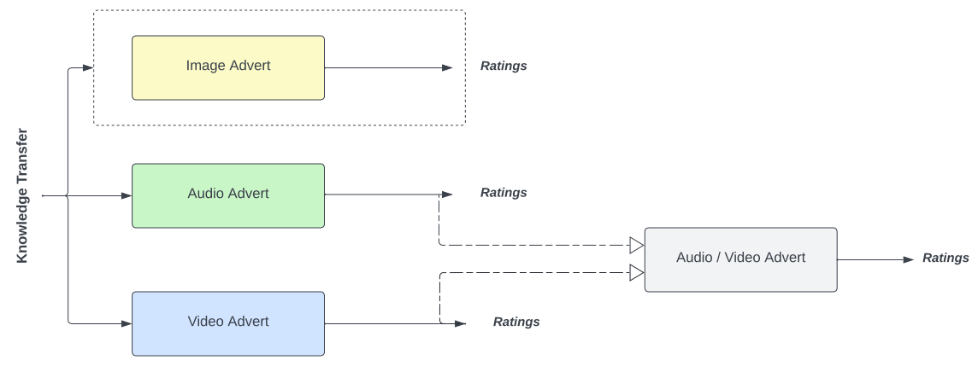

Figure 5.1: Proposed future work

References

[1] “EU’s creative sector ‘faces economic devastation from COVID’ | Culture | The Guardian.” https://www.theguardian.com/culture/2021/jan/26/eu-creative-sector-faces-economic-devastation-from-covid (accessed Jan. 04, 2022).
[2] “Europe: online ad spend 2006-2020 | Statista.” https://www.statista.com/statistics/307005/europe-online-ad-spend/ (accessed Jan. 04, 2022).
[3] “The Future of the Creative Economy A report by Deloitte,” 2021 (accessed May 04, 2022).
[4] “Dynamic Ad Insertion: Tips to Best Monetize Your Content,”
harmonicinc.com (accessed May 04, 2022).
[5] “AIDA Model - Understand the Steps in the AIDA Model Hierarchy,” corporatefinanceinstitute.com (accessed May 04, 2022).
[6] “Key Factors to Consider When Creating An Advert's Copy,”
thinkmarketingmagazine.com (accessed May 04, 2022).
[7] T. Mitchell, “Machine Learning (McGraw-Hill International Editions Computer Science Series) 9780071154673, pp. 414, 1997.
[8] M. Fire and J. Schler, “Exploring online Ad images using a deep convolutional neural network approach,” in Proceedings of IEEE Smart Data, pp. 20, 2017.
[9] X. Qin and Z. Jiang, “The Impact of AI on the Advertising Process: The Chinese Experience,” Journal of Advertising, vol. 48, no. 4, pp. 338–346, Aug. 2019, doi: 10.1080/00913367.2019.1652122/FORMAT/EPUB.
[10] J. Kietzmann, J. Paschen, and E. Treen, “Artificial intelligence in advertising: How marketers can leverage artificial intelligence along the consumer journey,” Journal of Advertising Research, vol. 58, no. 3, pp. 263–267, Sep. 2018, doi: 10.2501/JAR-2018-035.
[11] M. Kaput, “AI in Advertising: Everything You Need to Know,” https://www.marketingaiinstitute.com/blog/ai-in-advertising (accessed Jan. 04, 2022).
[12] D. Vakratsas and X. Wang, “Artificial Intelligence in Advertising Creativity,”, vol. 50, no. 1, pp. 39–51, 2020, doi: 10.1080/00913367.2020.1843090, https://doi.org/10.1080/00913367.2020.1843090. (accessed May 04, 2022).
[13] M. Ehsan, M. Director, and H. Kashif Iqbal, “The Impact of Advertisement and Consumer Perception on Consumer Buying Behavior,” International Review of Social Sciences and Humanities, vol. 6, no. 2, pp. 55–64, 2014, Accessed: Jan. 04, 2022. [Online]. Available: www.irssh.com (accessed May 04, 2022).
[14] A. Fahmi, K. Burc Ulengin, and C. Kahraman, “Analysis of Brand Image Effect on Advertising Awareness Using A Neuro-Fuzzy and A Neural Network Prediction Models,” Volume 10, Issue 1, 2017, Pages 690 - 710 ,2017.
[15] W.C. Wang, M. Manuela, S. Silva, and L. Moutinho, “Modelling Consumer Responses to Advertising Slogans through Artificial Neural Networks,” 2016. [Online]. Available: https://www.researchgate.net/publication/312190675(accessed May 04, 2022).
[16] S. Parthasarathy, R. Lotfian, and C. Busso, “Ranking Emotional Attributes with Deep Neural Networks,” Proceedings of IEEE International Conference on Acoustics, Speech and Signal Processing (ICASSP) doi 10.1109/ICASSP.2017.7953107.
[17] “Millward Brown: Knowledge Point MMIX Ia Should My Advertising Stimulate an Emotional Response?,” https://fliphtml5.com/ejut/nzkd/basic (accessed May 04, 2022).
[18] Sina Mohseni, Niloofar Zarei, and Eric D. Ragan, “A Multidisciplinary Survey and Framework for Design and Evaluation of Explainable AI Systems,” ACM Trans. Interact. Intell. Syst. 1, 1, Article 1, pp. 46 pages, January 2020. https://doi.org/10.1145/3387166 (accessed May 04, 2022).
[19] Ribeiro, Marco Tulio, Sameer Singh, and Carlos Guestrin “Why should I trust you? Explaining the predictions of any classifier,” In Proceedings of the 22nd ACM SIGKDD international conference on knowledge discovery and data mining, pp. 1135-1144, 2016.
[20] Sundararajan, Mukund, Ankur Taly and Qiqi Yan “Axiomatic attribution for deep networks,” In International Conference on Machine Learning, pp. 3319-3328, PMLR, 2017.
[21] https://medium.com/@kartikeyabhardwaj98/integrated-gradients-for-deep-neural-networks-c114e3968eae (accessed May 04, 2022).
[22] https://levelup.gitconnected.com/train-test-complexity-and-space-complexity-of-linear-regression-26b604dcdfa3 (accessed May 04, 2022).
[23] https://kasperfred.com/series/introduction-to-neural-networks/computational-complexity-of-neural-networks (accessed May 04, 2022).
[24] https://towardsdatascience.com/understanding-and-calculating-the-number-of-parameters-in-convolution--networks-cnns-fc88790d530d (accessed May 04, 2022).
[25] An Tien Vo, Hai Son Tran, Thai Hoang Le, “Advertisement Image Classification Using Convolutional Neural Network,” Proceedings of 9th International Conference on Knowledge and Systems Engineering, 2017, doi 10.1109/KSE.2017.8119458.
[26] Vaswani, Ashish, Noam Shazeer, Niki Parmar, Jakob Uszkoreit, Llion Jones, Aidan N. Gomez, Łukasz Kaiser, and Illia Polosukhin, “Attention is all you need,” Advances in neural information processing systems, Vol. 30, 2017.

Appendices

A1 and A2 appendicles represent the step by step implementation of the logistic regression modelling and CNN modelling for the scenario 1 explained in section 4.

A1. Data Collection

A2. CNN Model

A3. LIME Mode

A4. Integrated Gradient Model

